Optimize npm install
Evry Step That are written inside the Dockerfile all are the layes
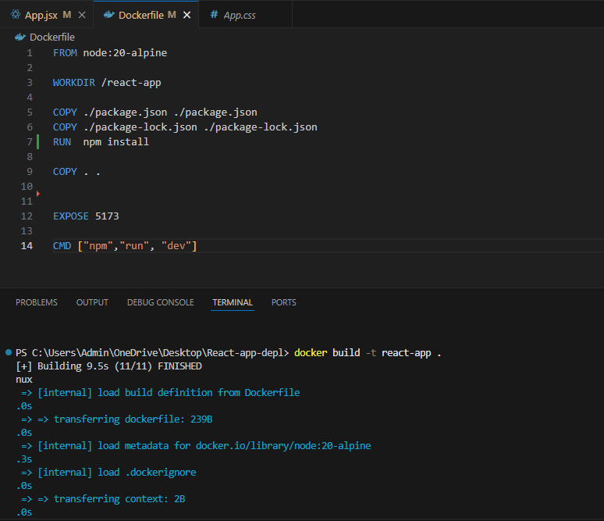

Volumes
Basically Docker forget all the past session are data if we stop the container.
So we use Docker Volume to store the data and make it persists.
- docker create volume app_volume
- docker volume ls
- Element | - Purpose
- -d | - Run container in background
- --name mongoDB | - Easy reference name for the container
- -v appdb:/data/db | - Persist MongoDB data outside the container
- -p 27017:27017 | - Expose MongoDB to your host machine
- mongo | - Use the official MongoDB image from Docker Hub

Since I am already created a volume mongodb_data now I run that with the mongo image and attach that volume same during running the app I assign the volume to run with my app
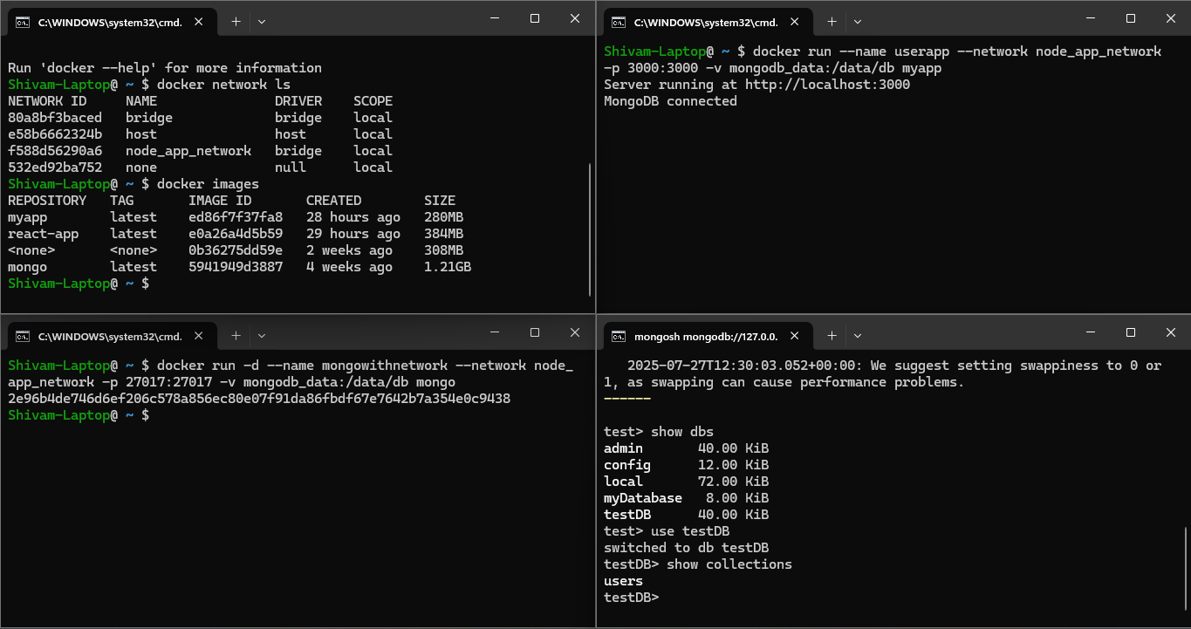

Network

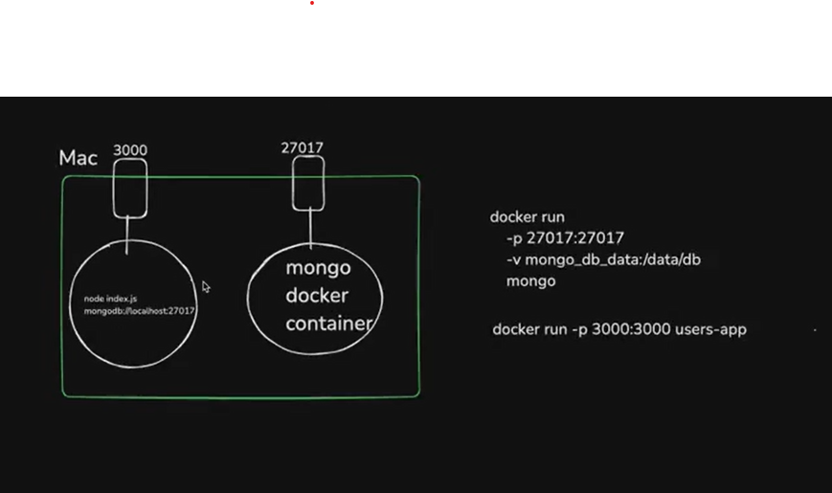
Here 2 container are isolated running one container is depend like in one container there is an Database logic but database is running on second container so how they talk each other this will be possible via docker Network Concept.

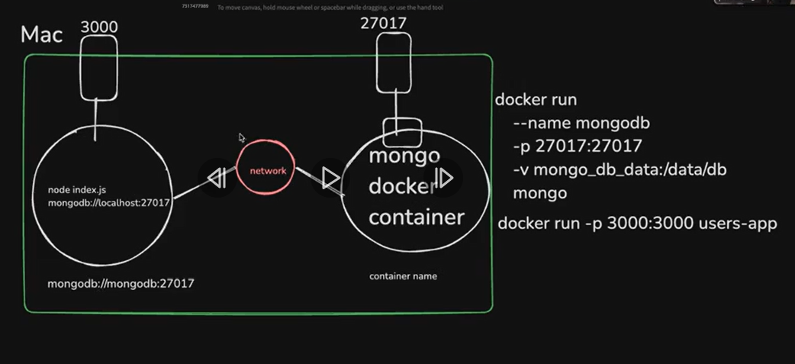
Create a network so that both can talk to each other every container name is equal to dns name.
>> docker network create network_name
>> docker ps ls
(list all the network created)

1. In this Given 4 Terminal in 1st terminal i listed my all network and my images.
2. In Second terminal i run MongoDB container attached it with the node_app_network and give
the name mongowithnetwork container name.
3. In third Terminal before running the app I changed the MongoDB url inside my code and write the
url mongodb://mongowithnetwork:27017/myDatabase and run the build command of app then build
command for docker to cache the latest changes. And then run the command.
docker run –-name userapp –network node_app_network -p 3000:3000 mapp
4. In forth terminal I go inside the running MongoDB container do client ssh and I got my DB name

